**VISVESVARAYA TECHNOLOGICAL UNIVERSITY**

**“Jnana Sangama”, Belagavi-590018, Karnataka**

**BANGALORE INSTITUTE OF TECHNOLOGY**

**K. R. Road, V. V. Puram, Bengaluru-560 004**

**DEPARTMENT OF COMPUTER SCIENCE & ENGINEERING**

**Computer Graphics Laboratory With Mini Project Report-18CSL67**

**on**

**“DASARA PROCESSION”**

**Submitted By**

**1BI20CS165 SNEHA C J**

**1BI20CS169 SOWMYA KANCHAN**

**for the academic year 2022-23**

Under the guidance of

**Prof. GUNAVATHI HS Prof. THANUJA N**

Assistant Professor Assistant Professor

**VISVESVARAYA TECHNOLOGICAL UNIVERSITY**

**“Jnana Sangama”, Belagavi-590018, Karnataka**

**BANGALORE INSTITUTE OF TECHNOLOGY**

**K. R. Road, V. V. Puram, Bengaluru-560 004**

**Department of Computer Science & Engineering**

***Certificate***

This is to certify that the implementation of **Computer Graphics Laboratory With Mini Project (18CSL68)** entitled **“DASARA PROCESSION”** has been successfully completed by

**1BI20CS165 SNEHA CJ**

**1BI20CS169 SOWMYA KANCHAN**

of VI semester B.E. for the partial fulfillment of the requirements for the Bachelor's degree in **Computer Science & Engineering** of the **Visvesvaraya Technological University** during the academic year **2022-2023**.

**Lab In charges:**

|  |  |  |
| --- | --- | --- |
| **Prof. Gunavathi H S.** | **Prof. Thanuja N.** | **Dr. Girija J.** |
| Assistant Professor | Assistant Professor | Professor and Head |

Dept. of CSE, BIT Dept. of CSE, BIT Dept. of CSE, BIT

Examiners: 1) 2)

**ACKNOWLEDGEMENT**

The knowledge & satisfaction that accompany the successful completion of any task would be incomplete without mention of people who made it possible, whose guidance and encouragement crowned my effort with success. I would like to thank all and acknowledge the help I have received to carry out this Mini Project.

I would like to convey my sincere thanks to **Dr. M. U. Aswath**, Principal, BIT and

**Dr. Girija J** , HOD, Department of CS&E, BIT for being kind enough to provide the necessary support to carry out the mini project.

I am most humbled to mention the enthusiastic influence provided by the lab in-charges **Prof. Gunavathi H S.,** and **Prof. Thanuja N.,** on the project for their ideas, time to time suggestions for being a constant guide and co-operation showed during the venture and making this project a great success.

I would also take this opportunity to thank my friends and family for their constant support and help. I'm very much pleasured to express my sincere gratitude to the friendly co-operation showed by all the **staff members** of Computer Science Department, BIT.

**Sneha C J**

**1BI20CS165**

**Sowmya Kanchan**

**1BI20CS169**

**Table of contents**

1. Introduction…………………………………………………………………1
   1. Computer Graphics………………………………………………… 1
   2. Application of Computer Graphics……………………………….. 1
   3. OpenGL…………………………………………………………… 3
   4. Problem Statement………………………………………………… 4
   5. Objective of The Project …….…………………………………… 4
   6. Organization of The Project..……………………………………… 5
2. System Specification ……………………………………………………... 6
   1. Hardware Requirements…………………………………………… 6
   2. Software Requirements……………………………………………..6
3. Design………………………………………………………………………7

3.1 Flow Diagram…………………………………………………………..7

3.2 Description of Flow Diagram…………………………………………..7

1. Implementation……………………………………………………………..8
   1. Built In Functions…………………………………………………..8
   2. User Defined Functions With Modules…………………………….9
   3. Psuedocode………..……………………………………………… 10
2. Snapshots…………………………………………………………………..20
3. Conclusion…………………………………………………………………23

Future Enhancement……………………………………………………….24

Bibliography……………………………………………………………….24

**CHAPTER -1**

**INTRODUCTION**

* 1. **Computer Graphics**

Computer graphics is an art of drawing pictures, lines, charts, using computers with the help of programming. Computer graphics is made up of number of pixels. Pixel is the smallest graphical picture or unit represented on the computer screen. Basically, there are 2 types of computer graphics namely,

Interactive Computer Graphics involves a two-way communication between computer and user. The observer is given some control over the image by providing him with an input device. This helps him to signal his request to the computer.

Non-Interactive Computer Graphics otherwise known as passive computer graphics it is the computer graphics in which user does not have any kind of control over the image. Image is merely the product of static stored program and will work according to the instructions given in the program linearly. The image is totally under the control of program instructions not under the user. Example: screen savers.

* 1. **Applications of Computer Graphics**

**Scientific Visualization :**

Scientific visualization is a branch of science, concerned with the visualization of three-dimensional phenomena, such as architectural, meteorological, medical, biological systems.

**Graphic Design:**

The term graphic design can refer to a number of artistic and professional disciplines which focus on visual communication and presentation.

**Computer-aided Design :**

Computer-aided design (CAD) is the use of computer technology for the design of objects, real or virtual. The design of geometric models for object shapes, in particular, is often called computer-aided geometric design (CAGD). The manufacturing process is tied in to the Computer description of the designed objects so that the fabrication of the product can be automated using that are referred to as CAM, Computer Aided Manufacturing.

**Web Design:**

Web design is the skill of designing presentations of content usually hypertext or hypermedia that is delivered to an end-user through the World Wide Web, by way of a Web browser.

**Digital Art:**

Digital art most commonly refers to art created on a computer in digital form.

**Video Games:**

A video game is an electronic game that involves interaction with a user interface to generate visual feedback on a raster display device.

**Virtual Reality:**

Virtual reality (VR) is a technology which allows a user to interact with a computer simulated environment. The simulated environment can be similar to the real world. This allows the designer to explore various positions of an object. Animations in virtual reality environments are used to train heavy equipment operators or to analyse the effectiveness of various cabin configurations and control placements.

**Computer Simulation:**

A computer simulation, a computer model or a computational model is a computer program, or network of computers, that attempts to simulate an abstract model of a particular system.

**Education and Training:**

Computer Simulations have become a useful part of mathematical modelling of many natural systems in physics, chemistry and biology, human systems in economics, psychology and social science and in the process of engineering new technology, to gain insight into the operation of those systems, or to observe their behavior. Most simulators provide screens for visual display of the external environment with multiple panels is mounted in front of the simulator.

**Image Processing :**

The modification or interpretation of existing pictures such as photographs and TV scans, is called image processing. In computer graphics, a computer is used to create a picture. Image processing techniques, on the other hand, are used to improve picture quality, analyse images, or recognize visual patterns for robotics application

* 1. **OpenGL**

OpenGL has become a widely accepted standard for developing graphics applications. Most of our applications will be designed to access OpenGL directly through functions in the three libraries. Functions in main GL libraries have names that begin with the letters gl and are stored in a library usually referred to as GL.

The second is the OpenGL Utility Library (GLU). This library uses only GL functions but contains code for creating common objects and simplifying viewing. All function   in GLU can be created from the core GL library. The GLU library is available in all OpenGL implementations. Functions in the GLU library starts with the letters glu.

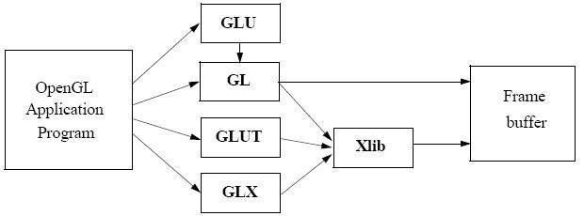

The third is the OpenGL Utility Toolkit (GLUT). It provides the minimum functionality that should be formulated in modern windowing system.

* 1. **Problem Statement**

Computer graphics involves the designing of objects in different forms which are regular and irregular in shape. The mini project named “Dasara Procession” creates 2D Mysore palace, ambari, tableaux, musicians and crowd. This project is designed and implemented using OpenGL interactive application that basically deals with providing the graphical interface between the user and the system. Through keyboard events the movement of musicians, tableaux and ambari along with multiple elephants have been implemented, which also includes day and night mode of Mysore palace. Using a drop down menu the color of the Mysore palace and street lights can be changed.

* 1. **Objectives of the Project**

1. Develop a Snowman and Android Scene: Create a visually appealing scene that includes a snowman and an android character.
2. Implement Environment Rendering : Create an environment surrounding the snowman and android characters. Include elements such as trees, mountains, or other relevant objects to enhance the scene's realism.
3. Enable User Interaction: Implement user interaction using input devices such as the mouse and keyboard.
4. Incorporate Animation and Dynamic Effects: Add animation effects to the scene, such as the movement of characters or objects.
5. To show the implementation of the OpenGL transformation functions.
   1. **Objectives of the Project**

* Visual Representation: One objective could be to create a visually appealing and realistic representation of a Dussehra procession using OpenGL.
* Real-Time Animation: This includes animating the movement of the procession, such as the floats, dancers, and other participants, to simulate a lively and dynamic environment.
* Lighting and EffectsThis includes simulating various lighting conditions such as sunlight, artificial lighting, and special effects like firecrackers or fireworks.
* User Interaction: This could involve allowing users to navigate through the procession scene, control the movement of specific objects, or even participate in certain activities associated with Dussehra, such as virtual games or mini-challenges.
* Cultural Accuracy: A significant objective could be to accurately represent the cultural aspects of the Dussehra procession
  1. **Organization of the Project**

The project was organized in a systematic way. First we analyzed what are the basic features to be included in the project to make it acceptable. As it is a graphics oriented project, we made the sketches prior, so as to have an idea like how our output must look like. After all these, the source code was formulated as a paper work. All the required software were downloaded. Finally, the successful implementation of the project.

**Chapter -2**

**SYSTEM SPECIFICATION**

**2.1 Hardware Requirements**

1. Main Processor: PENTIUM III
2. Processor Speed: 800 MHz
3. RAM Size: 128 MB DDR
4. Keyboard: Standard qwerty serial or PS/2 keyboard
5. Mouse: Standard serial or PS/2 mouse
6. Compatibility: AT/T Compatible
7. Cache memory: 256 KB
8. Diskette drive: 1,44MB,3.5 inches

**2.2 Software Requirements**

1. Operating System: Windows 10 or Linux (Fedora) or macOS
2. Hypervisor used: Docker
3. Compiler used: gcc
4. Language used: C language
5. Editor: Visual Studio Code
6. Toolkit: GLUT Toolkit

**Chapter -3**

**DESIGN**

**3.1 Flow Diagram**

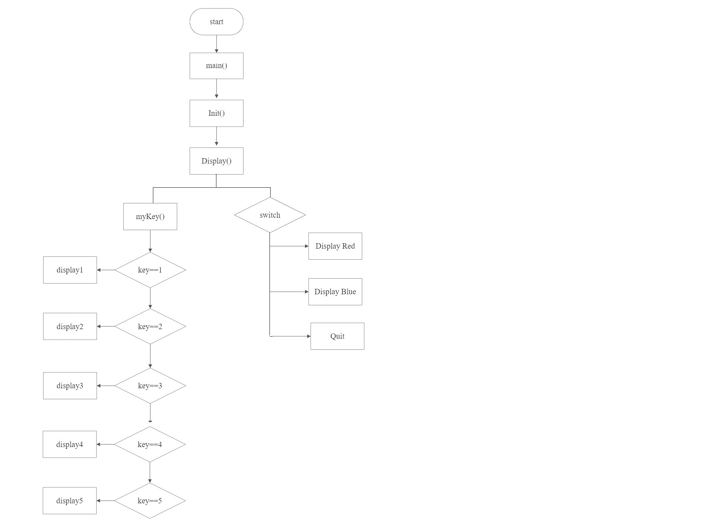

**3.2 Description of FlowChart**

The description of the flow diagram is as follows:

**Step1**: Start

**Step2**: The user can choose different options like mykey and menu.

**Step3**: Selecting menu option will take to select differnt menu options to select like display red,display blue and quit.

**Step4**: Selecting the mykeys options will take us to press any key like key1,key2,key3,key4 and key5 based on the key value selected respective display option will be selected like display1,display2,display3,display4,display5.

**Step5**: Stop

**Chapter -4**

**IMPLEMENTATION**

**4.1 Built in Functions**

1. **glutInit (int *argc, char **argv):** glutInit is used to initialize the GLUT library.
2. **glutInitDisplayMode(unsigned int mode):**glutInitDisplayMode sets the initial display mode.
3. **glutInitWindowPosition(intx,int y):** Specifies the initial position of the top-left corner of the window in pixels.
4. **glutInitWindowSize(intwidth,int height):** Specifies the initial height and width of the window in pixels.
5. **glutKeyboardFunc (void *f(char key,intwidth,int height):**KeyboardFunc sets the keyboard callback for the current window.
6. **glClear():**The clear function clears buffers to preset values.
7. **glClearColor(GLclampf r, GLclampf g, GLclampf b, GLclampf  a):**The glClearColor function specifies clear values for the color buffers.
8. **glMatrixMode(GLenum mode):**This function specifies which matrix is the current matrix.
9. **glLoadIdentity():** Set the current transformation matrix to an identity matrix.
10. **glPushMatrix(),glPopMatrix():** This pushes to and pops from the matrix stack corresponding to the current matrix mode.
11. **glPointSize():**The **glPointSize** function specifies the diameter of rasterized points.
12. **glTranslate[fd](TYPE x,TYPEy,TYPE z):** This function multiplies the current matrix by a translation matrix.
13. **gluOrtho2D(GLdouble left, GLdouble right, GLdouble bottom, GLdouble top):**The **gluOrtho2D** function defines a 2-D orthographic projection matrix.
14. **glBegin (glEnum mode):** It initiates a new primitive of type mode and starts the collection of vertices. Values of mode include GL_POINTS, GL_LINES, GL_LINE_STRIP, and GL_POLYGON.
15. **glEnd():**  It terminates a list of vertices.
16. **glFlush ():**It forces any buffered openGL commands to execute.
17. **glutMainLoop() :**Itcauses the program to enter an event processing loop.
18. **glutDisplayFunc(void (*func)(void)):**It registers the display function ‘func’ that is executed when the window needs to be redrawn.
19. **glutCreateMenu(void (*f)(void)):** It returns an identifier for a top-level menu and registers the callback function f that returns an interger value corresponding to the menu entry selected.

**4.2 User Defined Functions**

1. **elephant():** This function is used to draw an elephant carrying ambari.
2. **palace():** This function is used to draw the palace.
3. **chamundihill():** This function is used to draw the chamundi temple of Mysore.
4. **nightpalaceyellow():** This function is used to draw night mode of palace in yellow lights
5. **nightpalacered():** This function is used to draw night mode of palace in red lights.
6. **nightpalaceblue ():** This function is used to draw night mode of palace in blue lights.
7. **elephantpos():** This function is used to draw multiple elephants.
8. **elephant1 ():** This function is used to draw an elephant.
9. **fence():** This function is used to draw the fence.
10. **grass():** This function is used to draw the grass.
11. **roads():** This function is used to draw the roads.
12. **footpath():** This function is used to draw the footpath.
13. **mud():** This function is used to draw the mud.
14. **sky():** This function is used to draw the sky.
15. **streetlights():** This function is used to draw the street lights.
16. **circle1():** This function is used to draw the circle
17. **sun1 ():** This function is used to draw the sun.
18. **clouds ():** This function is used to draw the cloud.
19. **streetlightnight():** This function is used to draw the yellow colored street lights in night mode.
20. **streetlightnightred():** This function is used to draw the red colored street lights in night mode.
21. **streetlightnightblue():** This function is used to draw the blue colored street lights in night mode.
22. **nightfence():** This function is used to draw the fence in night mode.
23. **moon():** This function is used to draw the moon.
24. **stars():** This function is used to draw a star.
25. **disstars():** This function is used to draw the multiple stars.
26. **nightroad():**This function is used to draw the roads in night mode.
27. **translate():** This function is used to move the musicians.
28. **translate2():** This function is used to move the ambari along with other elephants.
29. **translate3():** This function is used to move the stabdhachitra.
30. **night1y(), night1r(), nightb():** This function is used to draw the side walls and dooms in yellow, red, blue respectively.
31. **night2y(), night2r(), night2b():** This function is used to draw the central portion of side walls in yellow, red, blue respectively

.

1. **night3y(), night3r(), night3b():** This function is used to draw the central portion of the palace in yellow, red, blue respectively.
2. **night4y(), night4r(), night4b():** This function is used to draw four dwarakas in yellow, red, blue respectively.
3. **night5y(), night5r(), night5b():** This function is used to draw small dwarakas beside main dwaraka in yellow, red, blue respectively.
4. **night6y(), night6r(), night6b():** This function is used to draw the main dwaraka in yellow, red, blue respectively.
5. **insidebox():** This function is used to draw the windows of the palace.
6. **hillpos():** This function is used to translate the tableaux.
7. **chariote():**This function is used to draw the tableaux of musical instruments.
8. **charioteele():**This function is used to draw the elephant  that moves the chariote.
9. **colors(int id):** This function is used to choose the menu entries.
10. **flute():** This function is used to draw the flute.
11. **man():** This function is used to draw the man.
12. **man1():** This function is used to draw the man.
13. **musicians():** This function is used to draw the musician.
14. **multiplemusicians():** This function is used to draw the multiple musicians.
15. **multipleman():**This function is used to draw men.
16. **scaleman():** This function is used to draw the crowd
17. **tr():** This function is used to draw the multiple trees.
18. **tree():** This function is used to draw a tree.

**4.3 PSEUDOCODE**

Void elephant ()

{

This function is used in the construction of an elephant carrying ambari.

}

Void palace ()

{

This function is used to draw the palace.

}

Void chamundihill ()

{

This function is used to draw the chamundi temple of Mysore.

}

Void nightpalacered ()

{

This function is used to draw the night mode of palace in red lights.

}

Void nightpalaceblue ()

{

This function is used to draw the night mode of palace in blue lights.

}

Void elephantpos ()

{

This function is used to draw the multiple elephants.

}

Void display (){

Color buffer is cleared by using glClear (),

This function displays the bit map characters.

glFlush () guarantees the execution of commands.

}

void mykeys(unsigned char key,int x,int y)

{

if(key=='1')display1();

else if(key=='2')display2();

else if(key=='3')display3();

else if(key=='4')display4();

else if(key=='5')display5();

else if(key=='6')display6();

else if(key=='9')display9();

}

void myinit()

{

glClearColor(1.0,1.0,1.0,1.0);

glColor3f(1.0,0.0,0.0);

glPointSize(3.0);

glMatrixMode(GL_PROJECTION);

gluOrtho2D(0.0,999.0,0.0,999.0);

}

void update(int value) {

_angle -= .5f;

if (_angle < 360) _angle += 360;

}

int main(int argc,char **argv)

{

glutInit(&argc,argv);

glutInitDisplayMode(GLUT_SINGLE|GLUT_RGB);

glutInitWindowSize(1000,1000);

glutInitWindowPosition(0,0);

glutCreateWindow("dasara procession");

glutDisplayFunc(display);

glutKeyboardFunc(mykeys);

glutTimerFunc(250, update, 0);

glutCreateMenu(colors);

glutAddMenuEntry("Red",1);

glutAddMenuEntry("Blue",2);

glutAddMenuEntry("Quit",3);

glutAttachMenu(GLUT_RIGHT_BUTTON);

myinit();

glutMainLoop();

}

void translate()

{float x=0;

for(int i=0;i<=500;i+=100)

{

glClear(GL_COLOR_BUFFER_BIT);

sky();

palace();

mud();

grass();

footpath();

scaleman();

fence();

tr();

roads();

clouds();

sun1();

streetlights();

glPushMatrix();

glTranslatef(x,0,0);

x=x-20.0;

musicians();

multiplemusicians();

man1();

multipleman();

glPopMatrix();

glFlush();

}

}

void translate2()

{ float x=0,y=0;

for(int i=0;i<=500;i+=100)

{

glClear(GL_COLOR_BUFFER_BIT);

sky();

palace();

mud();

grass();

footpath();

scaleman();

tr();

fence();

roads();

clouds();

sun1();

streetlights();

glPushMatrix();

glTranslatef(x,0,0);

x=x-9.0;

elephantpos();

elephant();

elephantpos();

glPopMatrix();

glFlush();

}

}

void display4()

{ glClear(GL_COLOR_BUFFER_BIT);

sky();

palace();mud();

grass();

footpath();scaleman();

tr();

fence();

roads();

clouds();

sun1();

streetlights();

elephant();

elephantpos();

glTranslatef(-500,0,0);

glFlush();

}

void sun()

{ glPushMatrix();

glTranslatef(-500,0,0);

sun1();

glPopMatrix();

}

void display1()

{ glClear(GL_COLOR_BUFFER_BIT);

sky();

mud();

grass();

footpath();

scaleman();

fence();

palace();

roads();

tr();

streetlights();

clouds();

sun1();

glFlush();}

void display2()

{

glClear(GL_COLOR_BUFFER_BIT);

translate();

glFlush();

}

void display5()

{

glClear(GL_COLOR_BUFFER_BIT);

translate2();

glFlush();

}

void translate3()

{

GLfloat x=0.0;

for(int i=0;i<1500;i+=200)

{

glClear(GL_COLOR_BUFFER_BIT);

sky();

palace();

mud();

grass();

footpath();

scaleman();

fence();

roads();

clouds();

sun1();

streetlights();

tr();

glPushMatrix();

glTranslatef(x,0,0);

x=x-20.0;

hillpos();

chariote();

glPopMatrix();

glFlush();

}

}

void translate4()

{

GLfloat x=0.0;

for(int i=0;i<1500;i+=100)

{

glClear(GL_COLOR_BUFFER_BIT);

sky();

palace();

mud();

grass();

footpath();

scaleman();

fence();

roads();

clouds();

sun1();

streetlights();

tr();

glPushMatrix();

glRotatef(-x,1,0,0);

x=x-9.0;

hillpos();

chariote();

glPopMatrix();

glFlush();

}

}

void display3()

{ glClear(GL_COLOR_BUFFER_BIT);

translate3();

glFlush();

}

void display6()

{ glColor3f(0.0,0.0,0.0);

glClear(GL_COLOR_BUFFER_BIT);

disstars();

nightpalaceyellow();

insidebox();

moon();

nightfence();

nightroad();

streetlightsnight();

glFlush();}

**Chapter 5**

**SNAPSHOTS**

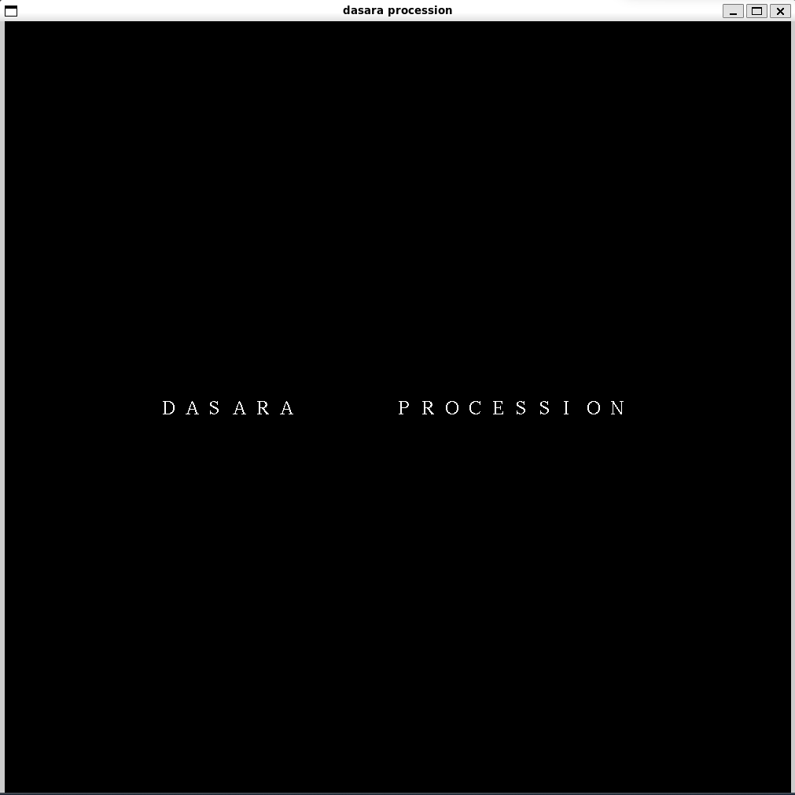

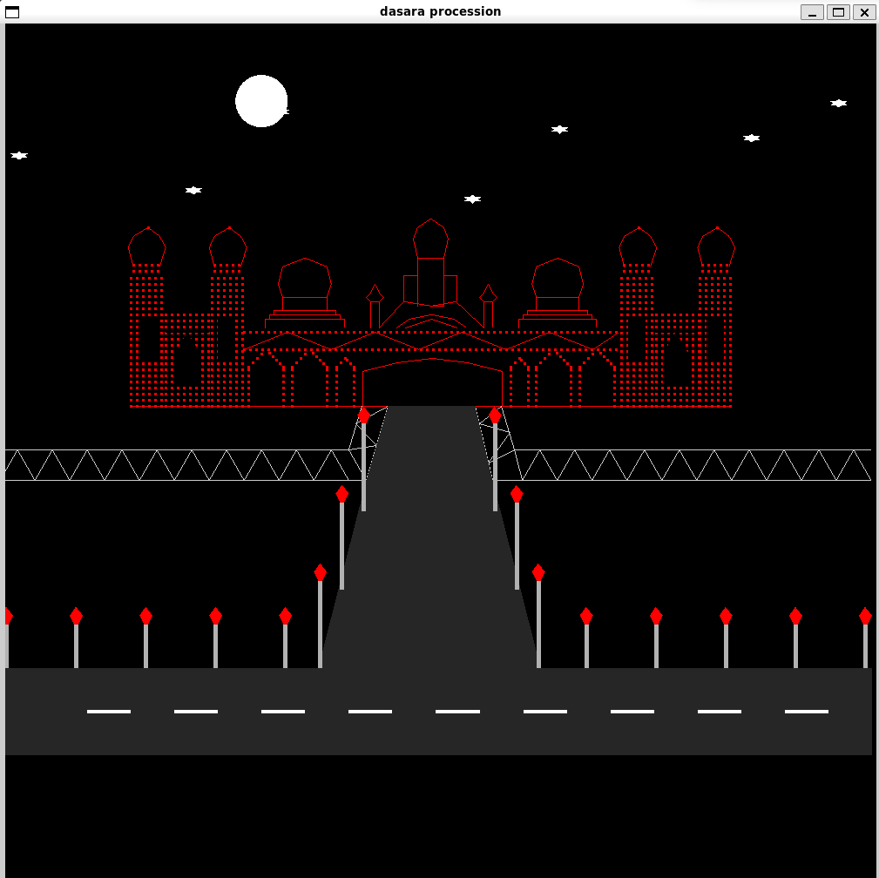

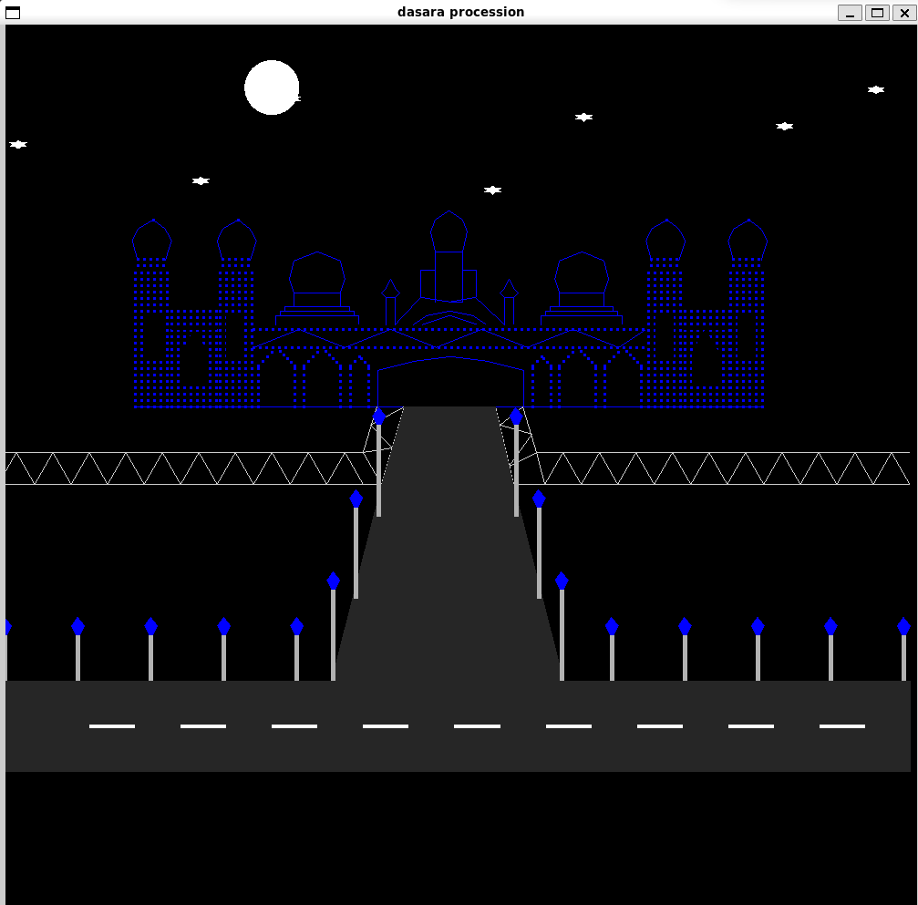

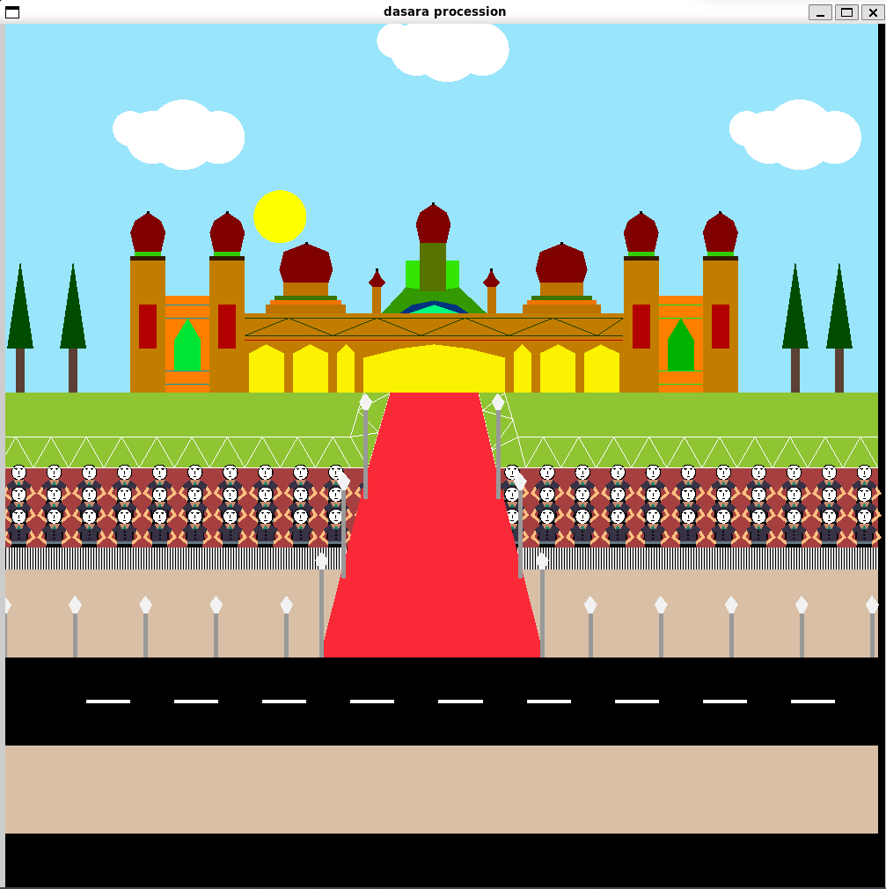

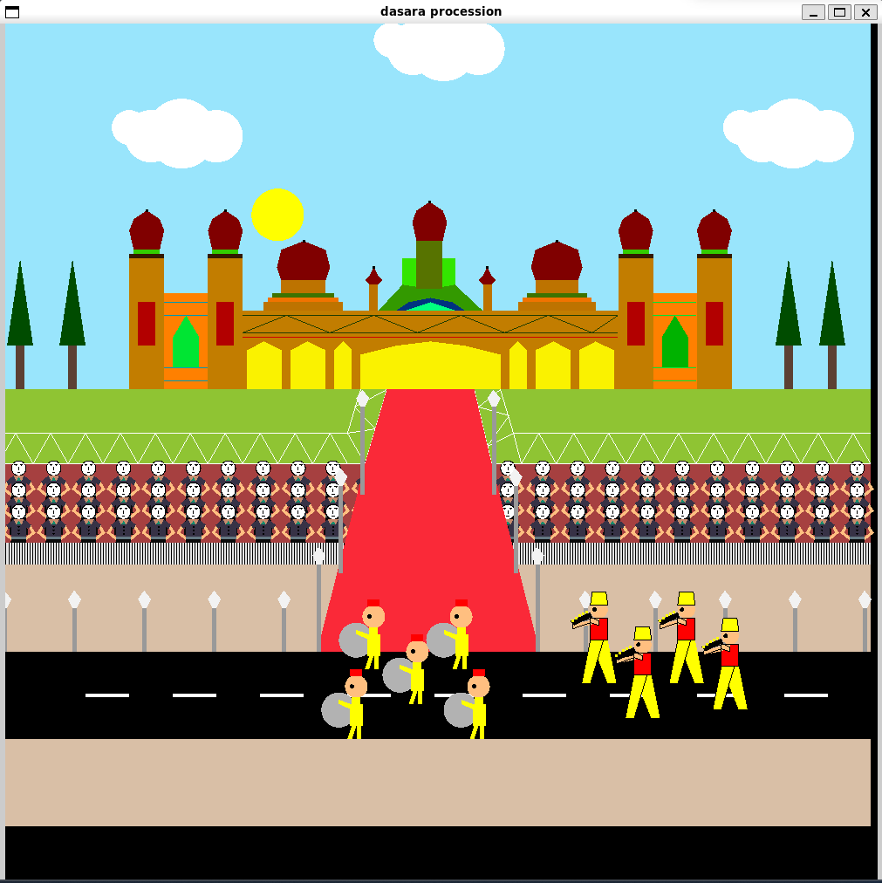

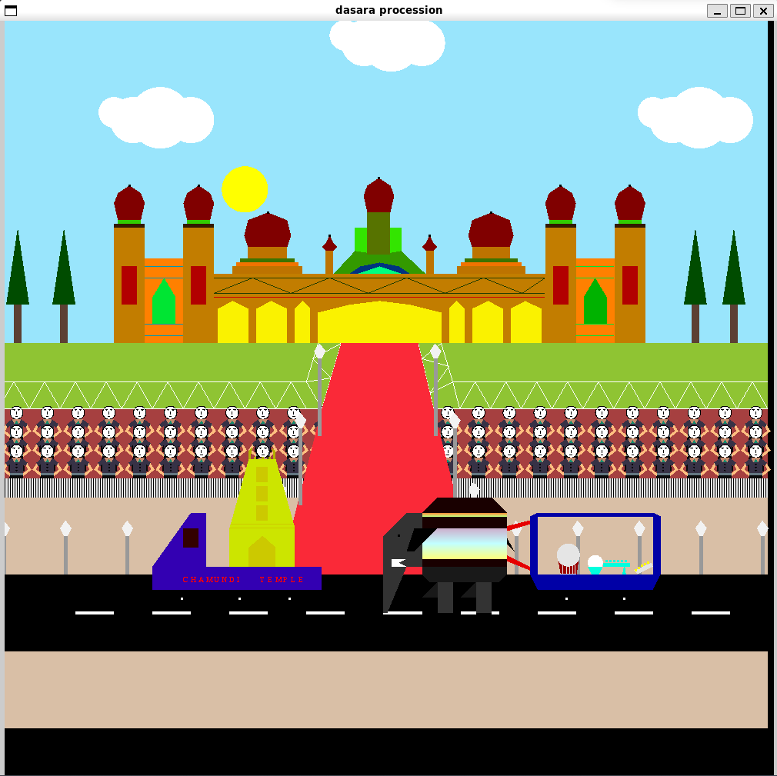

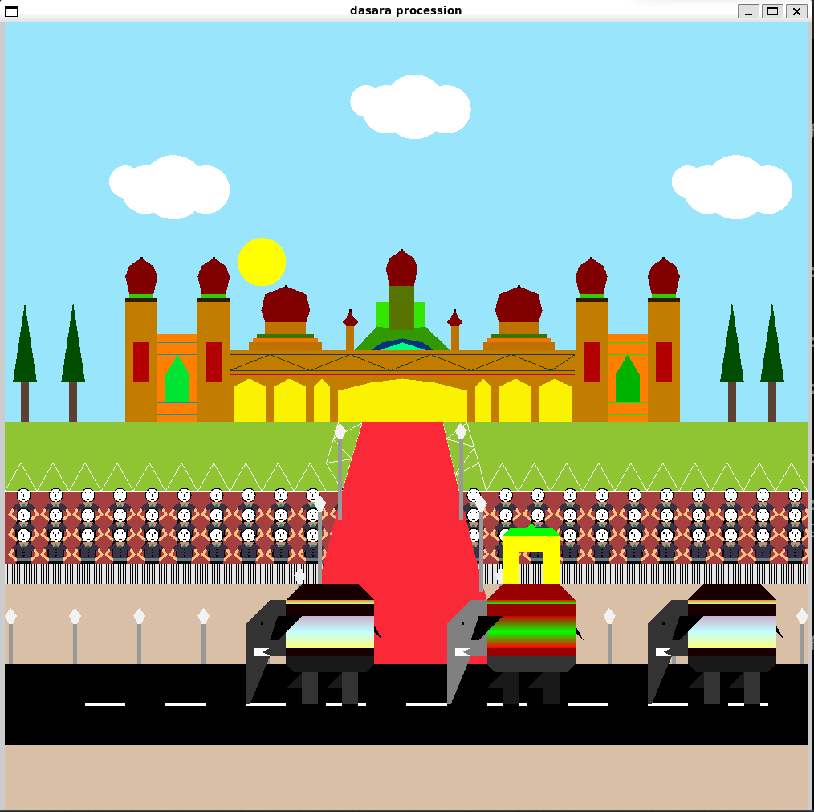

**Chapter 6**

**CONCLUSION**

In conclusion, the Dussehra procession OpenGL project aims to create an immersive and visually captivating representation of a Dussehra procession using the OpenGL graphics library. The project involves designing and implementing real-time animation, incorporating lighting and effects, enabling user interaction, optimizing performance, and ensuring cultural accuracy.

Overall, this project combines computer graphics, real-time animation, interactivity, and cultural representation to create a visually stunning and informative experience, providing users with a virtual glimpse into the vibrant celebration of Dussehra.

* 1. **Future Enhancements**

1.A vast amount of future work can be possible by following investigations and strategies.

2.More features can be included and can be modified in a more versatile way.

3. Advanced Animation Techniques: Implement more sophisticated animation techniques to bring the procession to life. This can involve realistic character animations, crowd simulations, and complex object interactions to create a dynamic and lively environment.

4. Customization and Personalization: Allow users to customize and personalize their experience. This can include options to change costumes, modify the environment, or select different music or audio tracks, enabling users to tailor the experience to their preferences.

**BIBLIOGRAPHY**

**Reference Books**

[1] Donald Hearn & Pauline Baker: Computer Graphics with OpenGL Version, 3rd/4th Edition, Pearson Education, 2011

[2] Edward Angel: Interactive Computer Graphics- A Top Down approach with OpenGL, 5th Edition, Pearson Education

[3] James D Foley, Andries Van Dam, Steven K Feiner, John F Huges Computer Graphics with OpenGL, Pearson Education

[4] Macro Cantu: Mastering Delphi

**Websites**

[1] <https://www.opengl.org/>

[2] <https://learnopengl.com/>